|  |  |
| --- | --- |
|  |  |

**eProject Document**

|  |  |
| --- | --- |
| **Group 4** | |
| **Members** | Nguyen Truong Giang – Student B8865 (Team Leader)  Dinh Quang Truong – Student B8848  Ngo Viet Anh – Student B8786 |
| **Instructor** | Doan Van Nang |
| **Batch** | C1909I2 |
| **Semester** | I |

**🙠 Date of issue 06-11-2020 🙢**

**Table of Content**

1. **Problem definition**
   1. ***Introduction***
   2. ***Existing Scenario***
   3. ***Proposed scenario***
2. **Customer Requirement Specification**
   1. ***Customer Requirement***
   2. ***Hardware – Software Requirements***
3. **Problem Definition**
   1. **Introduction**

Shale-PIZZAAsss is a little independent pizza company I founded in Nottingham in the year 1960. Our 'thing' is that we use restaurant grade ingredients on pizza. No pre-made plastic sauces, no anonymous poor quality meat and no sticky pre-grated cheese. We love to feature award winning, free range and locally sourced produce. We cook our fresh toppings from scratch, meaning we avoid the processed and the dubious and take pride in a twist or a quirk in our selections. People sometimes ask us what we do to make the pizza so good but honestly, it's no-one thing. It's a just a lot of little details.

* 1. **Hardware – Software requirement**

### Minimum Hardware Requirements

* CPU: Pentium IV 2.00 GHz.
* RAM: 512 MB.
* Hard Disk: 5 GB.
* OS: Window 2000/XP/Server 2003.

### Recommended Hardware Requirements

* CPU: Dou Core 2.00 GHz or higher.
* RAM: 2 Gb or higher.
* Hard Disk: 80 GB or higher.
* OS: Window XP SP3 / Window 7

### Software Requirements

* Environment: Microsoft .NET Framework 2.0 or later
* Database Management System: Microsoft SQL Server 2005 or later
* IDE: Microsoft Visual Studio 2008 or later
* Web Server: Internet Information Services (IIS 7.0) or later

1. **Task Sheet**

|  |  |  |  |  |  |  |
| --- | --- | --- | --- | --- | --- | --- |
| **Project Ref. No: 1** | | Project Title: Nexus Service Marketing System | **Date of Preparation of Activity Plan** | | | |
| **Sr. No.** | **Task** | | **Actual Start Date** | **Actual Days** | **Team Member Names** | **Status** |
| 1 | Header | |  | 7 | Ngo Viet Anh | complete |
| 2 | Menu | | Ngo Viet Anh | complete |
| 3 | Slide | | Ngo Viet Anh | complete |
| 5 | Index content | | Ngo Viet Anh | complete |
| 6 | Footer | | Dinh Quang Truong | complete |
| 7 | Blog content | | Dinh Quang Truong | complete |
| 8 | Report page | | Dinh Quang Truong | complete |
| 9 | About content | | Nguyen Truong Giang | complete |
| 10 | Contact us | | Nguyen Truong Giang | complete |
| 11 | Menu content | |  |  | Nguyen Truong Giang | complete |

HOW TO USE ERPROJECT

Step 1: First you need to have a sublime text software

Step 2: Embed the folder in the sublime text editor with the open folder option as shown below.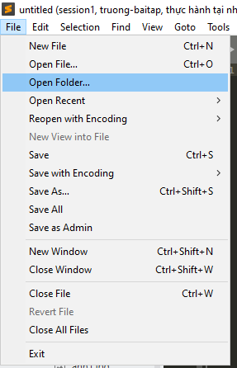

Step 3: After embed the folder, the sublime text editor screen will look like below.

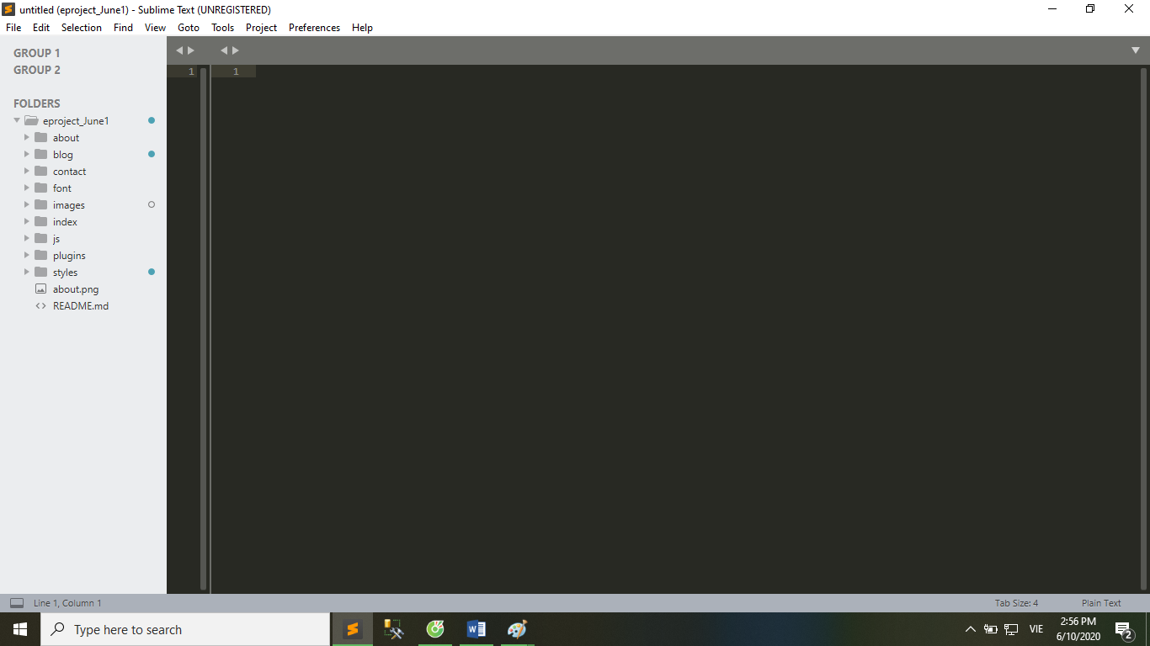

You can select the file you want to open from the list displayed on the left side of the screen, as shown in the image below.

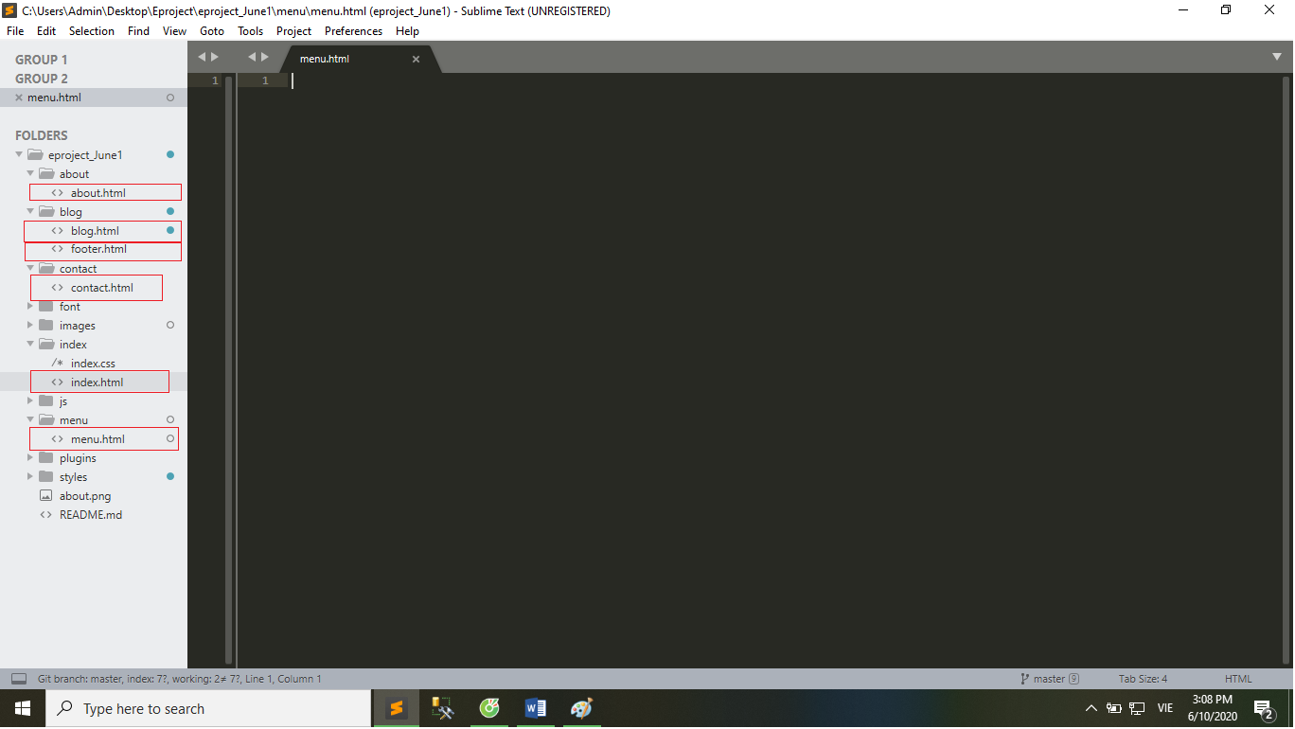

Note that the color combination helps identify the keywords and packages included in the code

To access the home page, select the index.html file in the index folder, right click as shown below.

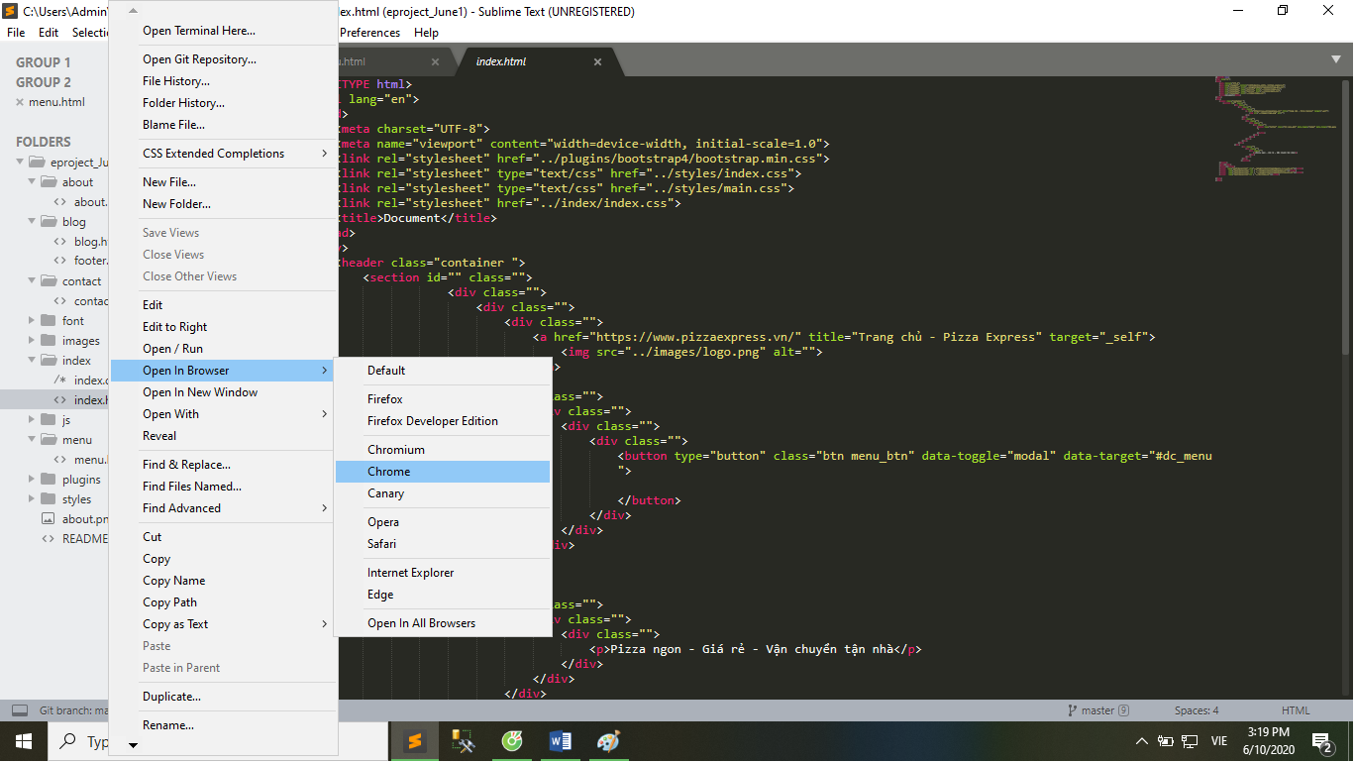

Here we choose the default browser is chrome.

Then the homepage is displayed.

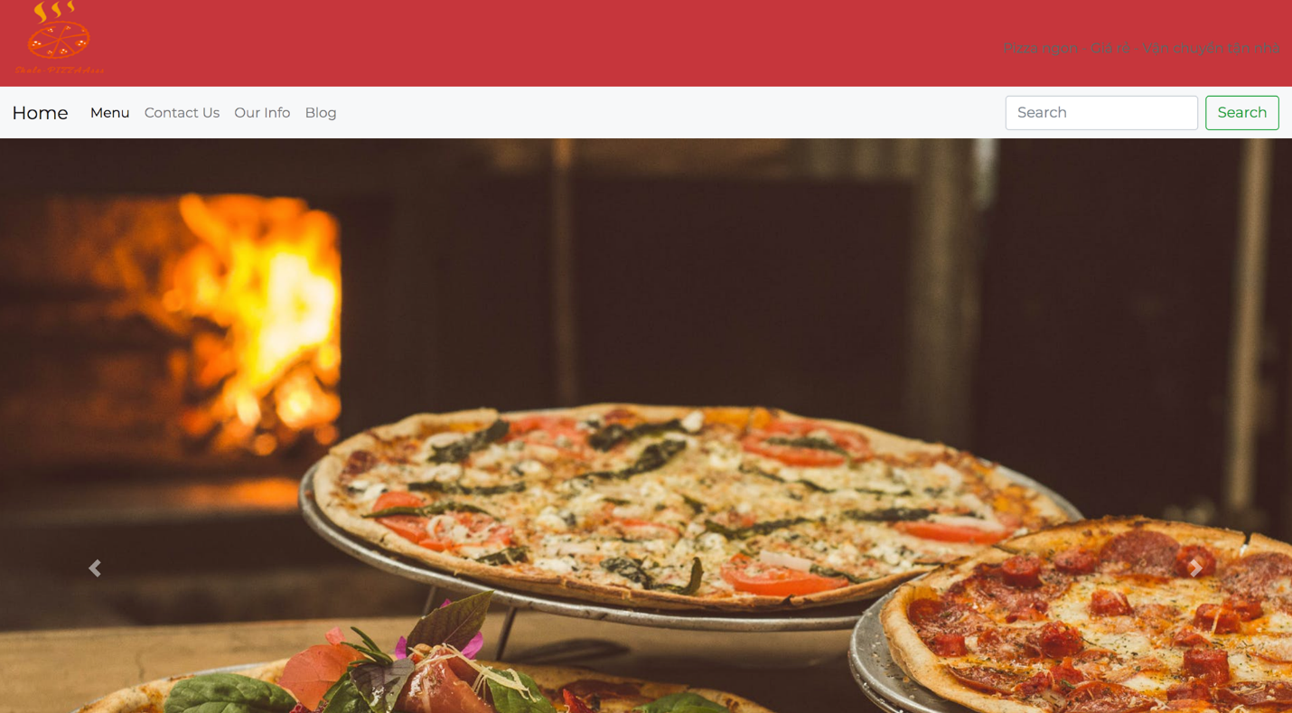

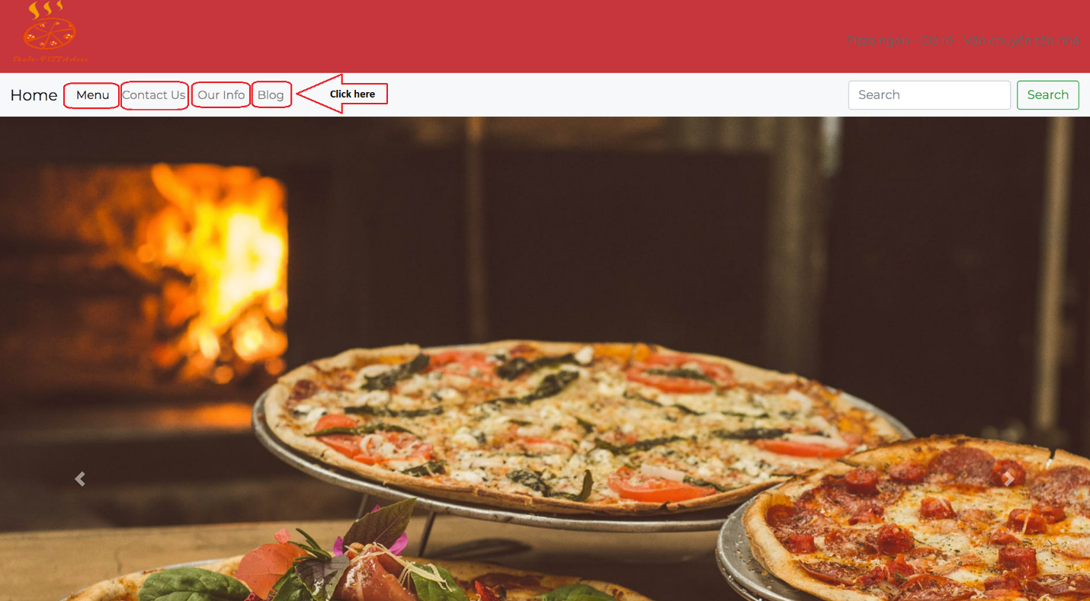 Or open from sublime text similar to how to access the homepage via the index.html file.

You can change the logo as you like.



By changing the logo1.png image in the images folder.

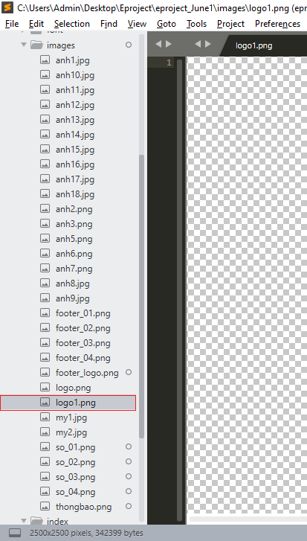

In the contact page you can change the map position as you like.

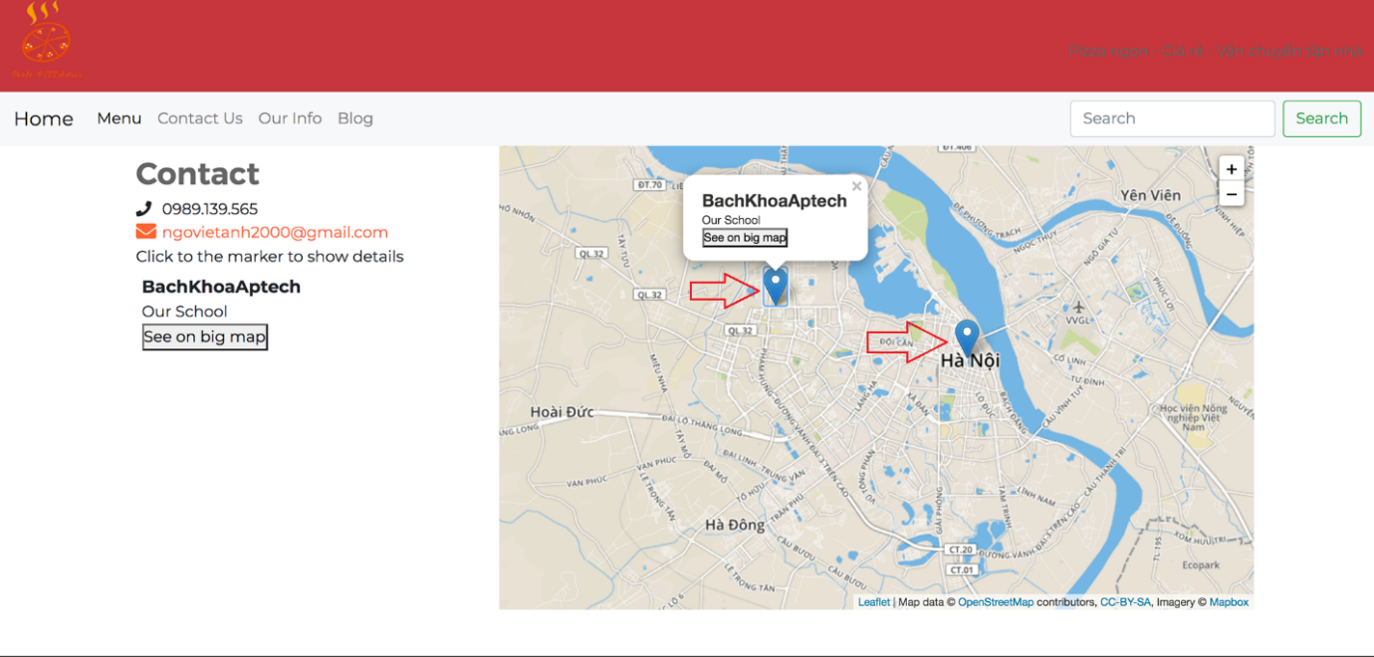

By changing the following parameters.

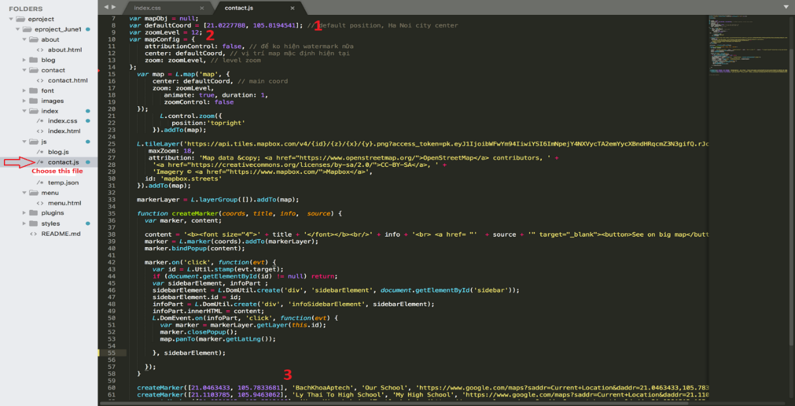

Note :

1: Central position of the map.

2: zoom level of the map.

3: optional parameters.

Optional parameters included:

1. Coordinates marker
2. Marker name
3. Related information.
4. Link coordinates marker in Google Maps

Through the above instructions we hope to bring you the best experience. Send feedback to Email: ngovietanh2000@gmail.com

**THE END**